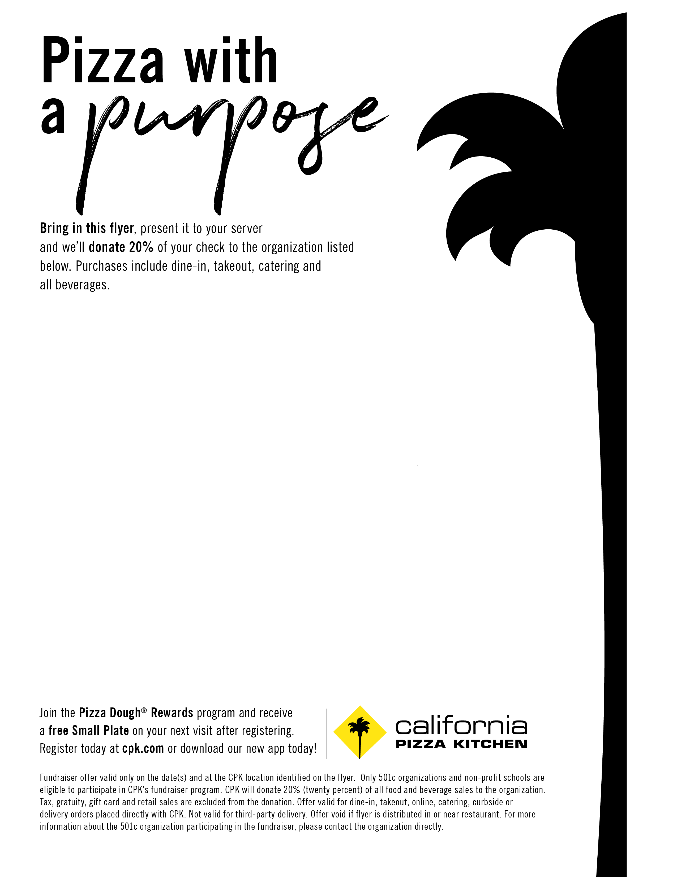

**Valid at the following location:**

**California Pizza Kitchen**

**1256 Old Country Road  
Westbury, NY 11590**

**(516) 683-3338**

**At the Westbury Shopping Plaza (Near Costco)**

***RESERVATIONS RECOMMENDED***

**Fundraiser in support of:**St. Thomas Malankara Orthodox Church  
April 6, 2018  
(All Day)